**Objectives:**

* to practice working with ***if* statements**

**Instructions:**

1. Examine the following programs and determine the results shown to the user. There is no need to run these programs -- the goal is to be able to answer questions like this without using the computer. Get your work checked off during lab so we can address any misconceptions you may have.

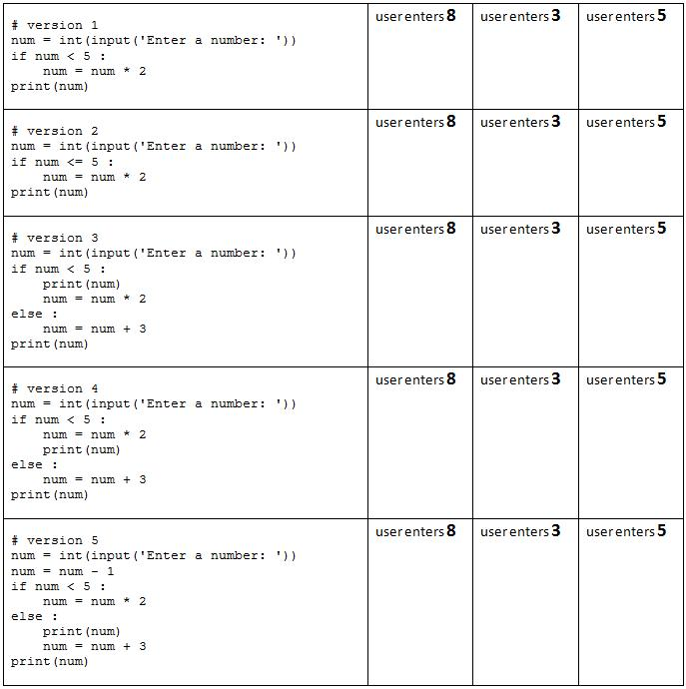

1. Determine the **value** and the **data type** (see Section 3.6 beginning on page 111 in the third edition of the Gaddis textbook) of each of the following expressions. *If you wish*, you may use the IDLE "shell" window to ***verify*** your results, but the goal is to be able to solve expressions like this ***without*** the computer. Again, just finding out the answers is ***NOT*** the goal. Being able to evaluate expressions ***without the computer*** is the goal!

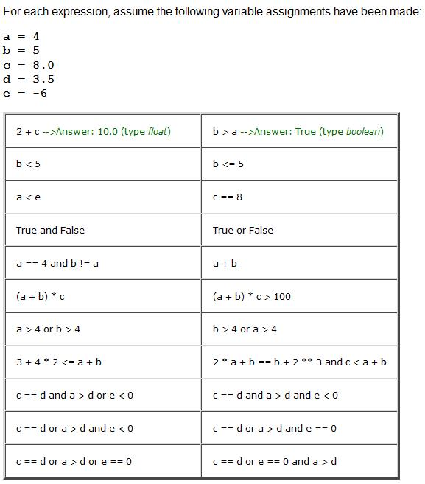

Turn in your completed work at the beginning of the next class meeting at the latest.